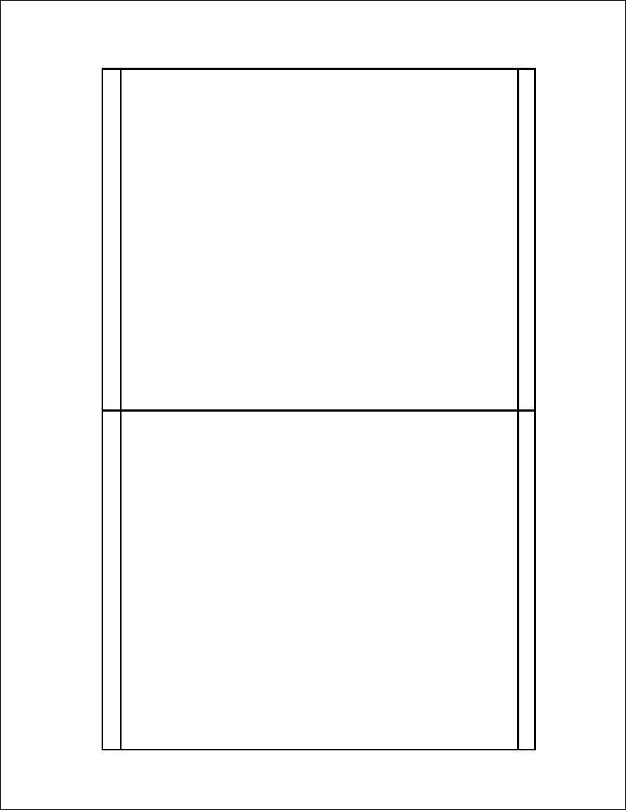
CDB578 Template
Professional Label, Inc. www.prolabel.com

